## PROGRAM DEFINITION

|  |
| --- |
|  |
| * A program to print a report for a list of revenue shares based on each unit for each agreement |

## RELATED TABLES

|  |  |
| --- | --- |
|  | **Access** |
| * - | * - |

## ROLES

|  |  |
| --- | --- |
|  | **Test** |
| * User that has access to program |  |

## INITIAL PROCESS

|  |  |
| --- | --- |
|  | **Test** |
| * Set **VAR_COMPANY_ID** = Login User’s Company ID * Set **VAR_USER_ID** = Login User ID * Set **VAR_LANGUAGE_ID** = Login User’s Language ID * Execute this stored procedure, save the results to **VAR_YEAR_RANGE**   **EXEC RSP_GS_GET_PERIOD_YEAR_RANGE**  **VAR_COMPANY_ID**  ,''  , ''   * - |  |

## MAIN FORM

### USER INTERFACE

#### INITIAL VERSION

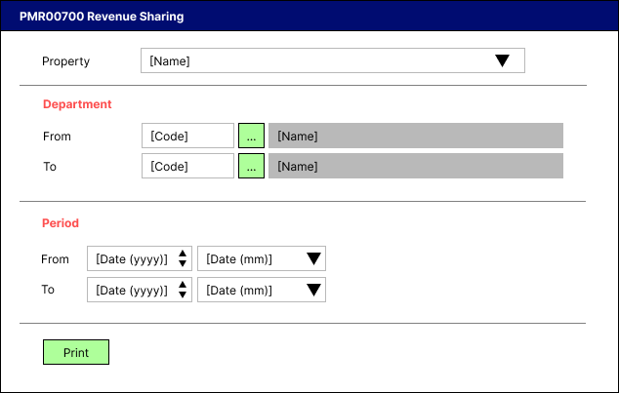

### BUTTON DEFINITION

|  |  |
| --- | --- |
| **Button Name** | **Action** |
| Print | Run PRINT REPORT PROCESS |

### DISPLAY PROCESS

#### FIELD DEFINITION

|  |  |  |  |
| --- | --- | --- | --- |
| **Name** | **Field** | **Type** | **Validation** |
| Property |  | Combo box  Set VAR_PROPERTY_LIST with  EXEC RSP_GS_GET_PROPERTY_LIST  VAR_COMPANY_ID  , VAR_USER_ID  Set property id = CPROPERTY_ID  Set property name = CPROPERTY_NAME  Set default selected property id = top 1 property id from VAR_PROPERTY_LIST.  Show name from the specific property id | * Mandatory * - |
| Department [From] |  | Lookup | * Mandatory * Enter lookup program GSL00700 with parameters: VAR_COMPANY_ID, VAR_USER_ID   And save the result to VAR_DEPARTMENT_FROM_RESULT   * If VAR_ DEPARTMENT_FROM_RESULT is empty, then: * Display message “Department [From] [INPUT Department Code] not found!”, [OK] * Set focus to Department From field * Else if VAR_DEPARTMENT_FROM_RESULT exists, then set department from name = CDEPT_NAME * - |
| Department [To] |  | Lookup | * Mandatory * Enter lookup program GSL00700 with parameters: VAR_COMPANY_ID, VAR_USER_ID   And save the result to VAR_DEPARTMENT_TO_RESULT   * If VAR_ DEPARTMENT_TO_RESULT is empty, then: * Display message “Department [To] [INPUT Department Code] not found!”, [OK] * Set focus to Department To field * Else if VAR_DEPARTMENT_FROM_RESULT exists, then set department to name = CDEPT_NAME * - |
| Period [From][Year] |  | Spinner  Spinner value:   * Minimum = VAR_YEAR_RANGE.IMIN_YEAR * Maximum = VAR_YEAR_RANGE.IMAX_YEAR   Set default spinner value:  SELECT YEAR(dbo.RFN_GET_DB_TODAY (VAR_COMPANY_ID)) | * Mandatory * - |
| Period [To][Year] |  | Spinner  Spinner value:   * Minimum = VAR_YEAR_RANGE.IMIN_YEAR * Maximum = VAR_YEAR_RANGE.IMAX_YEAR   Set default spinner value:  SELECT YEAR(dbo.RFN_GET_DB_TODAY (VAR_COMPANY_ID)) | * Mandatory * - |
| Period [From][Month] |  | Combo box  Set VAR_PERIOD_FROM_MONTH_LIST with  EXEC RSP_GS_GET_PERIOD_DT_LIST  VAR_COMPANY_ID  , (Period [From][Year])  Set month number = CPERIOD_NO  Set month name = January, February, … , December  Set default combo box value month name based on  SELECT MONTH(dbo.RFN_GET_DB_TODAY (VAR_COMPANY_ID)) | * Mandatory * - |
| Period [To][Month] |  | Combo box  Set VAR_PERIOD_TO_MONTH_LIST with  EXEC RSP_GS_GET_PERIOD_DT_LIST  VAR_COMPANY_ID  , (Period [To][Year])  Set month number = CPERIOD_NO  Set month name = January, February, … , December  Set default combo box value month name based on  SELECT MONTH(dbo.RFN_GET_DB_TODAY (VAR_COMPANY_ID)) | * Mandatory * - |

### PRINT REPORT PROCESS

#### REPORT LAYOUT

PAPER SIZE: A4 LANDSCAPE

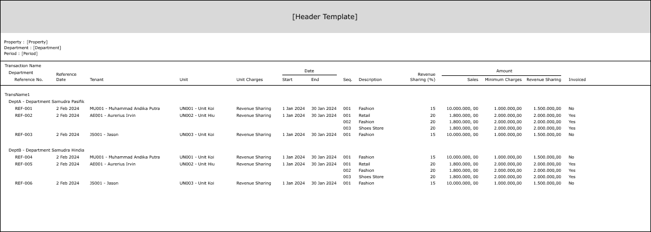

#### REPORT DEFINITION

|  |  |  |  |
| --- | --- | --- | --- |
| **Report** | **Name** | **Field** | **Validation** |
| **HEADER** | Property | Selected Property ID – Property Name |  |
| Department | Selected Department ID – Department Name (From & To) | IF Department [From] <> Department [To], then “Name[From] (ID [From]) – Name[To] (ID [To])”  ELSE, “Name[From] (ID [From])”  Ex. 1 Selected from : yyy – Department Y  Selected to : zzz – Department Z  Hence, show “Department Y (yyy) – Department Z (zzz)”  Ex. 2  Selected from : yyy – Department Y  Selected to : yyy – Department Y  Hence, show “Department Y (yyy)” |
| Period | Selected Period [From] – Period [To] | IF Period [From][Year] and Period [From][Month] <> Period [To][Year] and Period [To][Month], then “MMMM yyyy – MMMM yyyy”  Ex. Period From = “200109” and Period To = “200110”, then show “September 2001 – October 2001”  ELSE, show only Period [From][Year] and Period [From][Month]  Ex. “September 2001” |
| **REPORT GROUP** | Transaction | CTRANS_CODE |  |
| Department | CDEPT_CODE |  |
| Reference No. | CREF_NO |  |
| GROUP BY TRANSACTION | Transaction Name | CTRANS_NAME |  |
| GROUP BY DEPARTMENT | Department | CDEPT_CODE - CDEPT_NAME |  |
| GROUP BY REFERENCE NO. | Reference No. | CREF_NO |  |
| Reference Date | CREF_DATE |  |
| Tenant | CTENANT_ID - CTENANT_NAME |  |
| Unit | CUNIT_ID - CUNIT_NAME |  |
| Unit Charges | CCHARGES_NAME |  |
| Start Date | CSTART_DATE |  |
| End Date | CEND_DATE |  |
| DETAIL | Seq. | CSEQ_NO |  |
| Description | CDESCRIPTION |  |
| Revenue Sharing (%) | NREVENUE_SHARING_PERCENTAGE |  |
| Sales Amount | NSALES_AMOUNT |  |
| Minimum Charges Amount | NMINIMUM_RENT_AMOUNT |  |
| Revenue Sharing Amount | NREVENUE_SHARING_AMOUNT |  |
| Invoiced | LINVOICED | IF LINVOICED = 1, then “Yes”  ELSE “No” |

#### VALIDATION

|  |  |  |
| --- | --- | --- |
| **Field** | **Condition** | **Validation Message** |
| Property | Empty | Please select Property! |
| Department [From] | Department [From [Code]] is empty | Please select Department (From)! |
| Department [To] | Department [To [Code]] is empty | Please select Department (To)! |
| Department [To [Code]] is higher than Department [From [Code]] | Department (To) is higher than Department (From) |
| Period [To] | Period [To] is higher than Period [From] | Period (To) is higher than Period (From)! |

#### ACTION

|  |
| --- |
|  |
| * Execute this stored procedure:   RSP_PMR00700_GET_REPORT  VAR_COMPANY_ID  , selected Property ID  , selected Department [From] ID  , selected Department [To] ID  , selected Period [From]  , selected Period [To]  , VAR_LANGUAGE_ID   * Ex.   EXEC RSP_PMR00700_GET_REPORT  'RCD'  , 'ASHMD'  , 'ACC'  , 'FIN'  , '202404'  , '202406'  , 'EN' |

# CR LIST

|  |  |  |
| --- | --- | --- |
| **CR** | **Description** | **Notes** |
|  |  |  |

#### TEMPLATE

#### VALIDATION

|  |  |  |
| --- | --- | --- |
| **Field** | **Condition** | **Validation Message** |
|  |  |  |
|  |  |  |

#### ACTION

|  |
| --- |
|  |
|  |